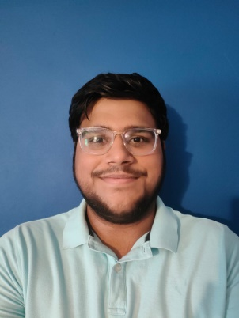MY NAME IS MUHAMMAD UMAIR GUL AND I AM CURRENTLY PURSUING ARTIFICIAL INTELLIGENCE IN FAST KHI.

I HAVE DONE MY SCHOOLING AND COLLEGE(O/A LEVELS) FROM THE CITY SCHOOL DK CAMPUS.

MY ACHIEVEMENTS FROM DK ARE

* 4 A’S IN O LEVELS, I WAS AMONGST THE HIGH ACHIEVERS.
* CAPTAIN OF THE CRICKET TEAM SINCE GRADE 4 , I HAVE WON MANY TOURNAMENT’S
* A PART OF BASKETBALL TEAM AND RECENTLY WE WON AN INTERBRANCH TOURNAMENT. I WAS THE MAN OF THE MATCH.
* MY HOBBIES ARE RIDING MY BIKE AND PLAYING SPORTS.
* I HAVE MY INTEREST IN CS BECAUSE IT IS THE FUTURE.